My Study Skill Analysis and Reflection

Name: Bibash Kumal
Section: C
Subject: CIS092-1 Fundamental of Software Engineer
Date: 20 Sept., 2026

1. My current approach to studying is mainly based on attending regular class, give attention to teachers, making-notes and complete all assignments before deadline. I also research more information to improve my understanding level high and research more from website, looks video when I don’t understand the topic. Sometimes, I used to study only during test and exam but now I have to be consistency more to make my study better with time table.

2. One study habit I want to show well is paying attention in class and make-notes in own words by listening to the lecturers. During the class I make-notes that’s help me to understand more on that topic and also help for me in assignments.

3. There are three study habits that I need to improve Firstly, avoid fully dependent on lecturers and start my work earlier. Second, I need to give progress review on my notes daily instead of reading at last during exam or unit test. Third, I need to reduce distraction from unnecessary thing like social media and phones while studying.

4. For note-taking method I used Cornell note making by dividing keywords or question, summary and note in different section which help me to understand clearly.

5. I will also use Mind Mapping technique to connect real ideas which help me to understand the complex topic by showing info and visual learning and make connection between ideas.

6. To manage my study time, I will make a time table and divide my class, assignments, revision and practical activities.

7. I will use the VLE responsibly by checking announcements regularly, submitting assignments on time and avoid copy writing.

8. One specific action I will begin this week follow a daily 30 minutes revision routine after classes.

Evidence to Include:
1. Cornell Note
Study skill Analysis and Reflection Date: 20 Sept., 2026
Keywords or Questions | Notes
- Making-notes  - Social media and phones  - Mind mapping  - VLE  - Daily revision  - Start work earlier  1. How can I reduce Distractions?  2. What is my note-taking method?  3. How can mind mapping help?  4. How will I manage time?  5. How will I use VLE responsibly?  What action will I start this week?  6. What do I need to improve? | Attend regular classes, pay attention to teachers, make notes, complete assignments before deadlines, and research additional information from websites and videos.  I need to study consistently instead of studying mainly during tests and exams.  Paying attention in class and making notes in my own words helps me understand topics and complete assignments.  Avoid depending completely on lecturers and start assignments and other work earlier.  Review notes every day instead of waiting until exams or unit tests.  Reduce unnecessary use of social media and phones while studying.  Use the Cornell Note-taking method by dividing notes into keywords/questions, detailed notes, and a summary.  Mind mapping connects ideas visually and makes complex topics easier to understand.  Create a timetable and divide time for classes, assignments, revision, and practical activities.  Check announcements regularly, submit assignments on time, and avoid copying other people's work.  Follow a daily 30-minute revision routine after classes.  Become more consistent, organized, independent, and responsible in studying.
Summary | My main goal is to improve my study habits by becoming more consistent and organized. I will attend classes, pay attention, make notes, revise daily, manage my time with a timetable, reduce distractions, and use the VLE responsibly. I will also use Cornell Notes and Mind Mapping to understand and remember topics better. My first specific action is to revise for 30 minutes every day after classes.
2. Mind Mapping:

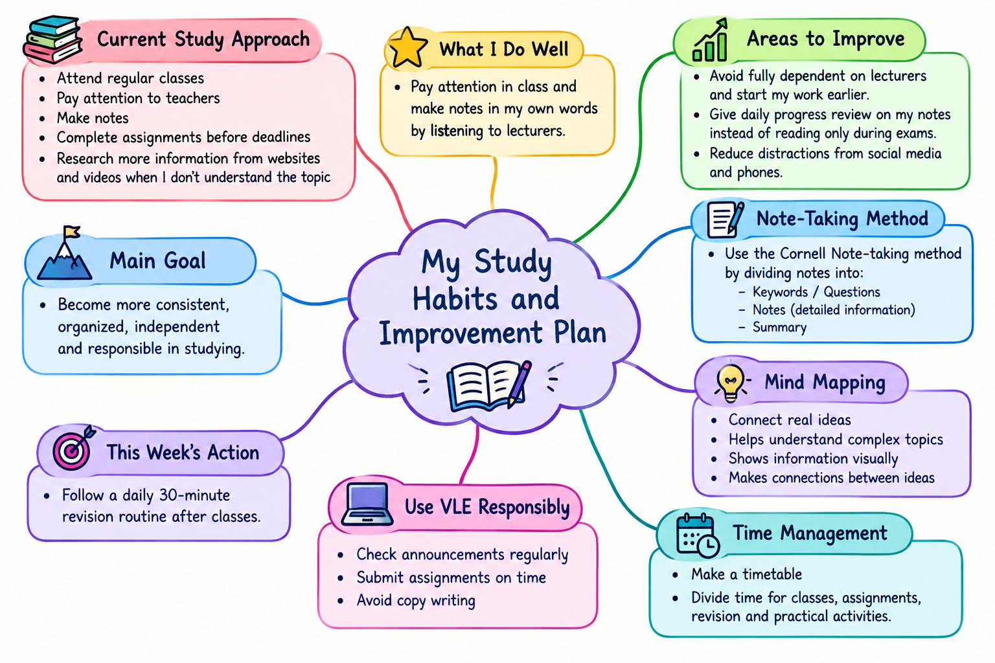

3. Weekly study time table:
Time | Sunday | Monday | Tuesday | Wednesday | Thursday | Friday | Saturday
5-5:30AM | Wake-up+Freshup | Wakeup+Freshup | Wakeup+Freshup | Wakeup+Freshup | Wakeup+Freshup | Wakeup+Freshup | Wakeup+Freshup
5:30-6AM | Exercise | Exercise | Exercise | Exercise | Exercise | Exercise | Exercise
6-7 AM | Breakfast | Breakfast | Breakfast | Breakfast | Breakfast | Breakfast | Breakfast
7-8:30AM | Study  revision | class | Study  revision | Study  revision | Study  revision | Study  revision | Study  revision
8:30-9am | Lunch | class | Lunch | Lunch | Lunch | Lunch | Lunch
9-10 am | Be ready and move to colllege | Class | Be ready and move to colllege | Be ready and move to colllege | Be ready and move to colllege | Be ready and move to colllege | Take rest and take bath
10am-3pm | Class session | Class session | Class session | Class session | Class session | Class session | Revise chapter and phone refreshment
3-4pm | Ready diet and go for gym | Ready diet and go for gym | Ready diet and go for gym | Ready diet and go for gym | Ready diet and go for gym | Ready diet and go for gym | Rest day  And phone refreshment
4-6pm | Gym | Gym | Gym | Gym | Gym | Gym | Pratice coding
6-6:30pm | Freshup | Freshup | Freshup | Freshup | Freshup | Freshup | Again rest
6:30-7:30pm | Dinner | Dinner | Dinner | Dinner | Dinner | Dinner | Dinner
7:30-9pm | Again revision | Again revision | Again revision | Again revision | Again revision | Again revision | Again revision
9-9:45pm | Look phone | Look phone | Look phone | Look phone | Look phone | Look phone | Look phone
9:45-5am | Sleep | Sleep | Sleep | Sleep | Sleep | Sleep | sleep

